InsightDraft: Enterprise Intelligent Document & Data Platform

1. Personal Information
Project Name: InsightDraft - Enterprise Intelligent Document & Data Platform

2. Description of Currently Ongoing Work
As knowledge workers, researchers, and analysts, we perform complex information synthesis daily to create business-critical reports. We must combine qualitative insights from hundreds of documents with quantitative data from numerous spreadsheets.

2.1. Document & Data Collection
- The Goal: Gathering all necessary information to answer a specific business question (e.g., "Create a Q4 performance review") from disparate enterprise systems.
- The Problem: Information is siloed. Documents live in different paths, while data lives in ERP exports and local CSVs. There is no unified search.
- The Manual Actions (What the Employee does):
  - The Scavenger Hunt: The employee manually searches multiple unrelated systems (SharePoint, Email, Shared Drives) using different keywords, hoping to find the "final" version of documents.
  - The Bulk Download: Since they can't preview effectively, they download 30-80 documents and 5-15 massive Excel files to their local machine.
  - The Organization: They manually create a folder structure, renaming files like Q4_Report_FINAL_v2.xlsx to try and organize the chaos before they even start reading.
  - The Verification: They open each file one by one to verify if it actually contains relevant information, discarding about 60% of what they downloaded.

2.2. Content Review & Analysis
- The Goal: Extracting meaningful insights and connecting the dots between what the documents say and what the data shows.
- The Problem: The volume of information exceeds human processing capacity. Reading 500 pages and analyzing 50,000 rows of data is cognitively overwhelming and error-prone.

- The Manual Actions (What the Employee does):
  - The Speed Read: The employee skims through hundreds of pages of PDF/Word documents, highlighting key sentences and manually typing notes into a "scratchpad" document.
  - The Spreadsheet Gymnastics: They open large Excel/CSV files, creating Pivot Tables and VLOOKUPs manually to calculate simple metrics like "Average Revenue" or "Year-over-Year Growth."
  - The Mental Correlation: They try to remember: "The strategy document said we focused on Asia, does the Excel file show sales growth in Asia?" They must manually cross-reference these separate sources.
  - The Source Tracking: They struggle to keep track of where each fact came from. "Did I see that 12% figure in the Q3 report or the Q4 forecast?"

2.3. Report Drafting & Formatting
- The Goal: Producing a professional, formatted report (DOCX/PDF) that synthesizes these findings for leadership.
- The Problem: Creating a polished document is a formatting nightmare. Hours are wasted on adjusting margins, aligning charts, and ensuring fonts match, rather than on the content itself.
- The Manual Actions (What the Employee does):
  - The Blank Page: They start writing from scratch, trying to turn their rough notes into professional prose.
  - The Copy-Paste Limits: They take screenshots of their Excel charts and paste them into Word. If the data changes, they have to redo the chart and re-paste it.
  - The Formatting Battle: They fight with Word to get the Table of Contents to update, the headers to align, and the images to stay where they put them.
  - The Citation Guesswork: They manually type "(Source: Q4 Financials)" at the end of sentences, often forgetting to update them if they move text around.

3. Implementation of AI to the Work
The idea is to have an Agentic System (Multi-Agent) for intelligent document retrieval, data analysis, and report generation. The system will act as an on-demand research analyst team that can read, calculate, and write.
This reduces the time for report creation from days to minutes, ensures 100% data accuracy through automated analysis, and creates a unified knowledge layer for the enterprise.

3.1 High-Level Architecture
We will design this using a Supervisor-Worker topology.
- The Dispatcher (The Interface): The single entry point for human requests ("Create a summary of Q4 risks"). It parses the intent and routes tasks to the correct sub-team.
- Team A: The Librarians (Knowledge Retrieval Unit): Responsible strictly for finding, reading, and extracting text from documents.
- Team B: The Analysts (Data Intelligence Unit): Responsible strictly for processing Excel/CSV files, performing statistical analysis, and generating charts.
- Team C: The Publishers (Report Generation Unit): Responsible for synthesizing inputs and creating the final professional document.
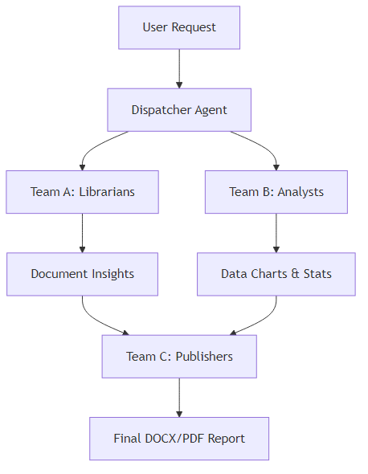
Figure 1: Multi-agent supervisor-worker topology

3.2 Detailed Agent Roles & Responsibilities

Team A: The Librarians (Knowledge Retrieval Unit)
- The Archivist (Search Agent):
  - Tools: Hybrid Search (BM25 + Vector), Metadata Filters.
  - Role: The "Fetcher." It takes a query ("Risks in Q4") and finds the top 20 most relevant document chunks from the knowledge base.
  - Capabilities: Understands semantic nuance (knows that "challenges" = "risks"). Filters by date, department, or file type.
- The Reader (Extraction Agent):
  - Tools: OCR, Docling/LayoutParser.
  - Role: The "Processor." It reads the raw files retrieved by the Archivist.
  - Capabilities: Distinguishes between main text, headers, and footnotes. Extracts tables from PDFs and converts them to structured data.

Team B: The Analysts (Data Intelligence Unit)
- The Statistician (Analysis Agent):
  - Tools: Python Pandas, NumPy, Scipy.
  - Role: The "Calculator." It takes a dataset and a question ("What is the trend?").
  - Capabilities: Cleans data (removes nulls, fixes formatting); Calculates specialized metrics (CAGR, Standard Deviation, Correlation); Detects anomalies ("Warning: Oct sales are 3x higher than Nov").
- The Artist (Visualization Agent):
  - Tools: Matplotlib, Seaborn, Plotly.
  - Role: The "Illustrator." It takes the stats from the Statistician and creates visual evidence.
  - Capabilities: Auto-selects the best chart type (Bar for categories, Line for time series). Generates high-DPI images for the report.

Team C: The Publishers (Report Generation Unit)
- The Synthesizer (Drafting Agent):
  - Tools: LLM (Context Window), Citation Manager.
  - Role: The "Writer." It combines the text from Team A and the stats/charts from Team B into a coherent narrative.
  - Capabilities: Writes in a professional business tone. Inserts inline citations [Source: document.pdf] automatically.
- The Typesetter (Formatting Agent):
  - Tools: python-docx, ReportLab (PDF).
  - Role: The "Formatter." It takes the text and applies the corporate style guide.
  - Capabilities: Generates Table of Contents, headers, footers, and page numbers. Ensures images are properly sized and aligned.

4. System Design & Technology Stack

The "Tool Loop" Workflow (Example)
Scenario: User asks "Summarize the financial performance of Project Alpha."
- Dispatcher receives request. Identifies "financial performance" (Data needed) and "Project Alpha" (Context needed).
- Dispatcher routes to Team A and Team B in parallel.
- Team A (Librarian) searches the knowledge base for "Project Alpha contracts" and "Project Alpha reviews". Retrieves 5 relevant PDFs.
- Team B (Analyst) loads Financials_2025.xlsx. Filters rows where Project = "Alpha". Calculates Sum(Revenue) and Sum(Cost).
- Artist Agent generates a "Revenue vs Cost" bar chart.
- Team C (Synthesizer) receives:
  - Text: "Project Alpha faced delays in Q3" (from PDF).
  - Data: "Q3 Costs increased by 40%" (from Excel).
- Synthesizer writes: "Project Alpha's profitability was impacted by execution delays in Q3 [Source: Review.pdf], resulting in a 40% cost spike [Source: Financials.xlsx]."
- Typesetter compiles this into a DOCX file and delivers it to the user.
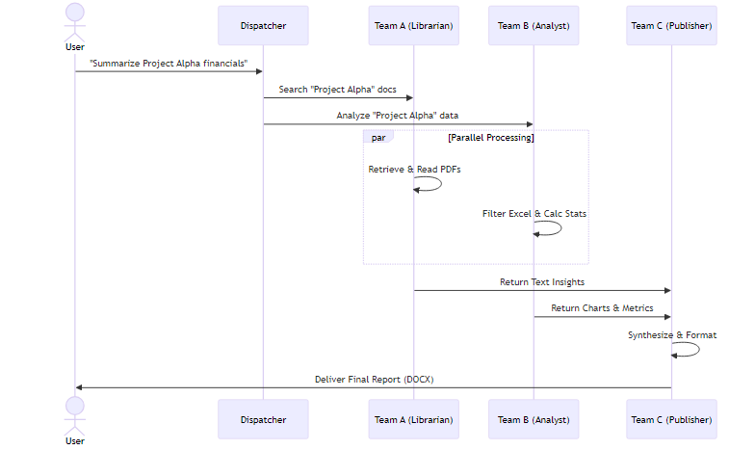
Figure 2: Example workflow for Project Alpha financial analysis

Technology Stack
- Orchestration: LangGraph (for Supervisor-Worker flow).
- Knowledge Base: PostgreSQL + pgvector (Hybrid Search).
- Data Processing: Pandas (Python).
- Document Parsing: Docling (IBM) / Unstructured.
- Generation: Hosted Local Instance LLMs only (e.g., Llama 3, Mixtral) - Data never leaves the premise.
- Output: python-docx.

Development Feasibility
- Resources Required: Development team: 2-3 developers from Agentic AI.
- Timeline: 3-month MVP (single knowledge base + Excel analysis + DOCX generation).
- Infrastructure: Standard enterprise cloud (PostgreSQL + pgvector, Python environment).
- LLM: On-premise deployment (Llama 3 / Mixtral).
- Technical Feasibility: 100% buildable with current enterprise technology stack. All components use proven open-source libraries.

Scalability Path
- Phase 1 (Month 1-3): Single knowledge base with 5,000 documents.
- Phase 2 (Month 4-6): Expand to 3-5 knowledge bases (15,000-25,000 documents).
- Phase 3 (Month 7-12): Enterprise deployment with 10+ knowledge bases (50,000+ documents).

5. Safety & "Human-in-the-Loop"
An autonomous agent generating business reports carries risks of hallucination. We implement strict tiers of safety.

- Tier 1 (Autonomous): Read-only operations (Searching KBs, Reading CSVs). Calculating statistics (deterministic code, not LLM guesses).
- Tier 2 (Human Approval Required): Finalizing the report.
  - Implementation: Before the final "Download" link is generated, the system creates a "Review Mode."
  - Verification: The user sees the draft with clickable citations.
  - Action: Users must click "Verify Sources" or manually edit a sensitive section before the final DOCX is stamped "Approved."

6. Effect of Agentic AI Application

Quantified Business Impact
- Time Reduction:
  - Traditional manual process: 40 hours per report (5 working days).
  - InsightDraft agentic process: 0.6 hours per report (35 minutes).
  - Time savings per report: 39.4 hours (98.5% reduction).

Enterprise-Wide Productivity Recovery
Metric | Conservative Estimate | Aggressive Estimate
Reports per month (organization-wide) | 500 | 1,000
Hours saved per report | 39.4 | 39.4
Monthly hours recovered | 19,700 hours | 39,400 hours
Annual hours recovered | 236,400 hours | 472,800 hours

- Productivity Impact:
  - Conservative adoption (50% of reports): 118,200 hours recovered annually.
  - Moderate adoption (70% of reports): 165,500 hours recovered annually.
  - Represents equivalent capacity of 59-82 full-time employees.

Qualitative Transformation

Category | The Manual "Pain" | The Agent Opportunity
Search | Manually logging into 4 systems; zip downloads. | Agent: Auto-queries all KBs/Data Lakes in seconds.
Analysis | Manual Pivot Tables; copying to Word. | Agent: Pandas scripts auto-calculate and chart.
Drafting | Writer's block; formatting struggles. | Agent: Instantly drafts narrative integrating data.
Accuracy | Reviewing 50 pages to check one number. | Agent: Every claim has a clickable citation link.
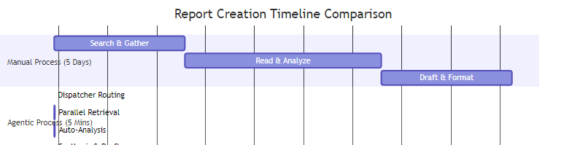
Figure 3: Time comparison - Manual vs Agentic process

Strategic Benefits
- Democratized Expertise: A junior analyst can produce a "Senior Strategist" level report because the Agent automates rigorous data correlation.
- Living Knowledge: System encourages uploading to the Knowledge Base, making every report smarter than the last.
- Cost of Curiosity: Asking "What if?" currently takes 3 days; with InsightDraft, it takes 3 minutes.
- Institutional Memory Preservation: Knowledge remains accessible even after senior employee retirement.

